**SSH Client side configuration**

**SSH using hostnames instead of IP address**

Edit /etc/hosts on local system to resolve your remote system’s name to its IP address

$ echo “192.168.33.11 centos2” | sudo tee -a /etc/hosts

Now your /etc/hosts file includes the resolved name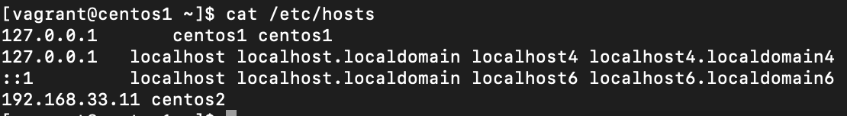

And you’re able to ssh using its hostname instead of your remote’s IP address

$ ssh centos2

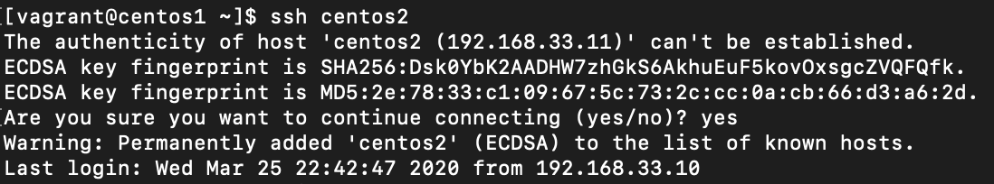

**Tips & Tricks**

To end an ssh session if and when it hangs

$ ~.

Using your ssh configuration file to include your typical arguments when ssh’ing

* Config file is /etc/ssh/ssh_config

Create a file for your client

$ touch ~/.ssh/config

$ chmod 600 ~/.ssh/config

Edit ~/.ssh/config:

# every entry except CentOS2-V6 will use port 22 and ed25519 key

Host * !CentOS2-V6

IdentityFile ~/.ssh/id_ed25519

Port 22

Host CentOS2-V4

Hostname 192.168.33.11

User vagrant

Host CentOS2-V6

Hostname fe80::a00:27ff:fe5c:7f1b%%eth1

IdentityFile ~/.ssh/id_rsa

Port 22

User vagrant

Host CentOS2-Hostname

Hostname centos2

User vagrant